学院网站英文版首页学术进展英文稿格式

1.Title: journal name | 论文题目 arial 18号字体

2.论文介绍：300-500 word，插入文章主要图件1-2张， arial 18号字体

3.论文信息：包括所有作者，论文题目，发表期刊，卷期号和Doi 号，论文链接或论文首页， arial 16号字体

4.参考模板

Geophysics | Dispersion and attenuation characteristics of an obliquely incident SV wave in a fluid-saturated porous rock containing aligned penny-shaped fractures

Owing to the complex structural characteristics of aligned fractured rocks with a fluid-saturated porous background, many existing single-wave attenuation mechanism models cannot accurately characterize measuring multiband shear vertical (SV) wave data. Moreover, the coupled effect of wave-induced fluid flow between fractures and the background (FB-WIFF) and elastic scattering (ES) from the fractures leads to ambiguity in the elastic response of the SV wave. Using Biot’s theory and mixed boundary constraints, the exact solutions of the scattering problem for a single penny-shaped fracture with an obliquely incident SV wave are derived.

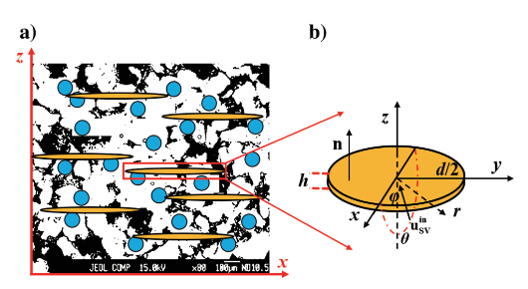

**Fig 1.**

Furthermore, a theoretical model for a set of aligned fractures is developed by using Foldy’s scheme. The numerical results indicated that the FB-WIFF, ES of fractures, and their coupling effects were mainly responsible for wave dispersion and attenuation. The FB-WIFF occurs primarily in the low-frequency seismic exploration frequency band, whereas the ES of the fracture surface depends on the relationship between the wavelength and fracture size. In addition, by comparing our model with an existing interpolation approximation model and previous experimental measurements, the accuracy and effectiveness of the model was validated. The results of this work can explain the acoustic response of SV-wave experimental data in different frequency bands and theoretically support fracture detection and characterization.

CITATION: Wen-Hao Wang, Sheng-Qing Li*, Jun-Xin Guo, Long Zhao, Shang-Jing Guo, Yuan-Da Su, Xiao-Ming Tang, 2024, Dispersion and attenuation characteristics of an obliquely incident SV wave in a fluid-saturated porous rock containing aligned penny-shaped fractures. Geophysics, 89(3), MR125–MR136, doi: <https://doi.org/10.1190/geo2023-0170.1>